 | 7.1.33 Editors - 3D Viewport - Header - Grease Pencil - Edit mode - Stroke menu
Table of content
Detailed table of content 1
Edit Mode - Stroke Menu 3
Subdivide 3
Subdivide and smooth 4
Simplify Strokes sub menu 5
Join sub menu 6
Outline 6
Move to Layer 7
Assign Material 7
Set as active material 8
Arrange Strokes sub menu 8
Close 8
Toggle Cyclic 8
Set Caps sub menu 9
Switch Direction 10
Set Start Point 10
Normalize Thickness 10
Normalize Opacity 10
Convert Type sub menu 10
Set Curve Resolution 10
Reset UVs 11

Detailed table of content
Detailed table of content
Detailed table of content 1
Edit Mode - Stroke Menu 3
Subdivide 3
Last Operator Subdivide 3
Number of Cuts 3
Smooth 3
Repeat 3
Selected Points 4
Position 4
Thickness 4
Strength 4
UV 4
Subdivide and smooth 4
Last Operator Subdivide 4
Number of Cuts 4
Selected Points 4
Iterations 4
Factor 4
Smooth Endpoints 4
Keep Shape 4
Position 4
Radius 5
Opacity 5
Simplify Strokes sub menu 5
Fixed 5
Adaptive 5
Sample 5
Merge 5
Last Operator Simplify Stroke 5
Mode 5
Steps (Fixed) 5
Factor (Adaptive) 5
Length (Sample) 5
Distance (Merge) 5
Join sub menu 6
Join and Copy 6
Join 6
Adjust last operator Join Selection 6
Type 6
Outline 6
Adjust last operator Outline 6
Projection mode 6
Radius 6
Offset Factor 6
Corner Subdivisions 6
Move to Layer 7
New Layer 7
Last Operator Move Strokes to Layer 7
Grease Pencil Layer 7
Assign Material 7
Last Operator Change Stroke Color 8
Material 8
Set as active material 8
Arrange Strokes sub menu 8
Bring Forward 8
Send Backward 8
Bring to Front 8
Send to Back 8
Last Operator Arrange Stroke 8
Direction 8
Close 8
Toggle Cyclic 8
Last Operator Set Cyclical State 9
Type 9
Close all 9
Open all 9
Toggle 9
Create geometry 9
Set Caps sub menu 9
Default 9
Both 9
Start 9
End 9
Last Operator Set Caps Mode 9
Type 9
Switch Direction 10
Set Start Point 10
Normalize Thickness 10
Normalize Opacity 10
Last operator Normalize Stroke 10
Mode 10
Value 10
Convert Type sub menu 10
Set Curve Resolution 10
Ajust last operator Set Curve Resolution 10
Resolution 10
Reset UVs 11

Edit Mode - Stroke Menu
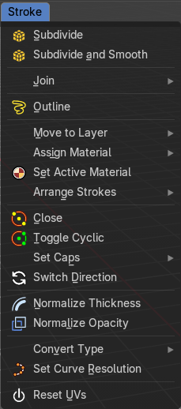
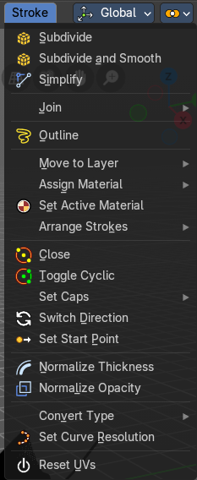
In Edit Mode you will also see a add menu for some object types. The number of objects that you can add is limited to the same object type that you are in edit mode with. You can just add mesh geometry to a mesh geometry. And just curve geometry to curve geometry.
The added objects in edit mode becomes part of the current object geometry.
The menu content changes dependant of the Select mode. In Select mode Stroke a few menu items are not displayed. Since they do not work in that mode.

Subdivide
Subdivides the selected grease pencil geometry.

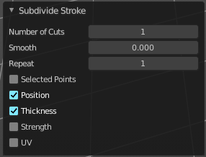
Last Operator Subdivide

Number of Cuts
Number of subdivision cuts.

Smooth
Smoothen the stroke, not just the new added vertices

Repeat
The number of times to repeat the procedure.

Selected Points
Limits the effect to only the selected points within the stroke.

Position
The operator affects the points location.

Thickness
The operator affect the points thickness.

Strength
The operator affect the points strength (alpha).

UV
The operator affect the UV rotation on the points.

Subdivide and smooth
Subdivides the selected grease pencil geometry, and smoothens it.

Last Operator Subdivide

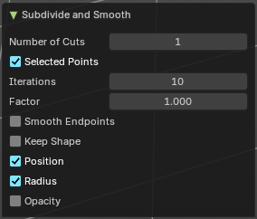
Number of Cuts
Number of subdivision cuts.

Selected Points
Limits the effect to only the selected points within the stroke.

Iterations
How often to smooth.

Factor
The smoothing factor

Smooth Endpoints
Smoothen the endpoints.

Keep Shape
Try to keep the original shape.

Position
The operator affects the points location.

Radius
The smooth radius around vertices.

Opacity
The smooth opacity.

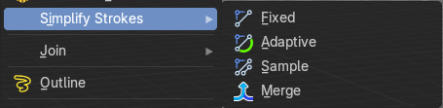
Simplify Strokes sub menu
Stroke mode. Simplify the stroke.

Fixed
Deletes every second point in the stroke, except the start and end points.

Adaptive
This method uses an algorithm called RDP algorithm (Ramer-Douglas-Peucker algorithm) for points deletion. The algorithm tries to keep the shape with the remaining points.

Sample
Samples points along the shape of the stroke, and increases the length of the edges.

Merge
Simplify the stroke by merging vertices closer than a given distance.

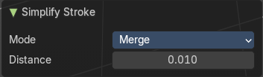
Last Operator Simplify Stroke
The simplify strokes operators share the same last operator.

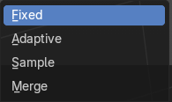
Mode
The method.

Steps (Fixed)
How much levels of simplifying.

Factor (Adaptive)
How strong the simplification should be performed.

Length (Sample)
The sample length.

Distance (Merge)
The distance. Below this value the vertices gets merged.

Join sub menu

Join and Copy
Copy the selection in the new stroke.

Join
Move the selection to the new stroke.

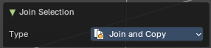
Adjust last operator Join Selection

Type
Choose the join method.

Outline
Convert selected strokes to perimeter.

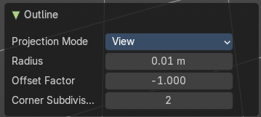
Adjust last operator Outline

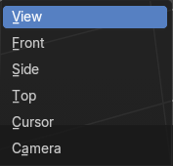
Projection mode
How to project the stroke.

Radius
How big.

Offset Factor
Offset from the stroke.

Corner Subdivisions
How much subdivisions at corners.

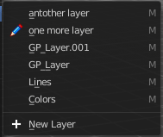
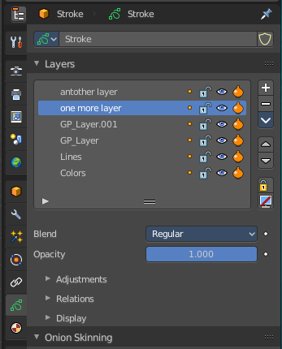
Move to Layer
Move the current selected stroke to another grease pencil layer. It lists the current layers.

New Layer
New Layer button adds a new grease pencil layer.

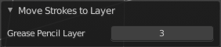
Last Operator Move Strokes to Layer

Grease Pencil Layer
Internal the layers are enumerated. So here you move by number.
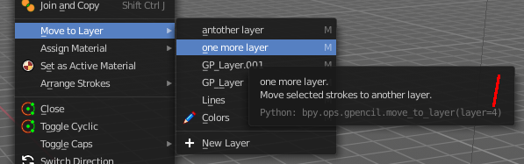
The number of a layer can be found out in the tool tip, in the Python part of it.

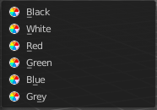
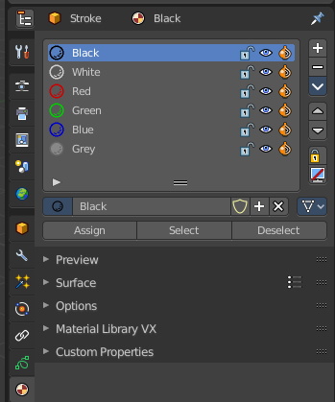
Assign Material
Assign a new material to the current selected stroke geometry.
The materials can be found and edited in the Properties editor. Here you can also create new materials.

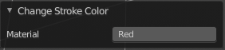
Last Operator Change Stroke Color

Material
The materials are defined by its name. So when you want to use another material, then change the name here.

Set as active material
Sets the current selected material as the active material.

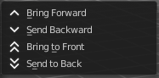
Arrange Strokes sub menu
Changes the drawing order of the strokes in the 2D layer.

Bring Forward
Moves the selected points/strokes upper the next one in the drawing order.

Send Backward
Moves the selected points/strokes below the previous one in the drawing order.

Bring to Front
Moves to the top the selected points/strokes.

Send to Back
Moves to the bottom the selected points/strokes.

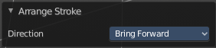
Last Operator Arrange Stroke

Direction
Choose the method again.

Close
Closes the current stroke by connecting the first vertice with the last vertice by a stroke. See also Toggle Cyclic.

Toggle Cyclic
When the curve is open, then it Closes the current stroke by connecting the first vertice with the last vertice by a stroke. When the curve is closed, then it removes the connection between first and last vertice, and makes the curve open.

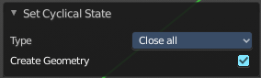
Last Operator Set Cyclical State

Type
Choose the method again.

Close all
Close all open selected strokes.

Open all
Open all closed selected strokes.

Toggle
Close or Open selected strokes as required.

Create geometry
When enabled, points are added for closing the strokes like when using the Close tool. If disabled, the stroke is closed with just one edge.

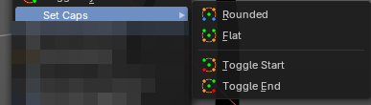
Set Caps sub menu
Toggles if the start and endpoints of the strokes are rounded or flat.
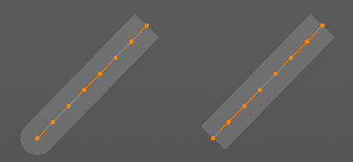

Default
Sets stroke start and end points to rounded (default).

Both
Toggle stroke start and end points caps to flat or rounded.

Start
Toggle stroke start point cap to flat or rounded.

End
Toggle stroke end point cap to flat or rounded.

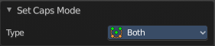
Last Operator Set Caps Mode

Type
Choose the method again.

Switch Direction
Switches the direction of the stroke geometry.

Set Start Point
Select which point is the start point of the grease pencil curve. This defines the order of point indices, useful for Geometry nodes.
Note: Not available in stroke selection mode.

Normalize Thickness
Adjust the thickness of the stroke.

Normalize Opacity
Adjust the opacity of the stroke.

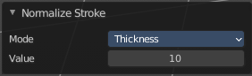
Last operator Normalize Stroke
This last operator works for both tools, Normalize Thickness and Normalize Opacity.

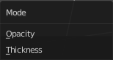
Mode
Adjust thickness or opacity.

Value
The value to adjust the opacity or thickness.

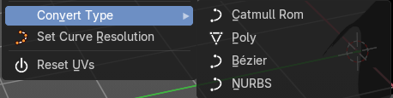
Convert Type sub menu
Set the curve type.

Set Curve Resolution
Set the resolution of the curve.

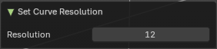
Ajust last operator Set Curve Resolution

Resolution
The resolution that you want to choose.

Reset UVs
Reset UV Transformation values to zero.

